Filed by Sustainable Opportunities Acquisition Corp. pursuant to

Rule 425 under the Securities Act of 1933

and deemed filed pursuant to Rule 14a-12

under the Securities Exchange Act of 1934

Subject Company: Sustainable Opportunities Acquisition Corp.

Commission File No. 001-39281

The following communication was made available by DeepGreen Metals Inc. on LinkedIn on March 19, 2021:
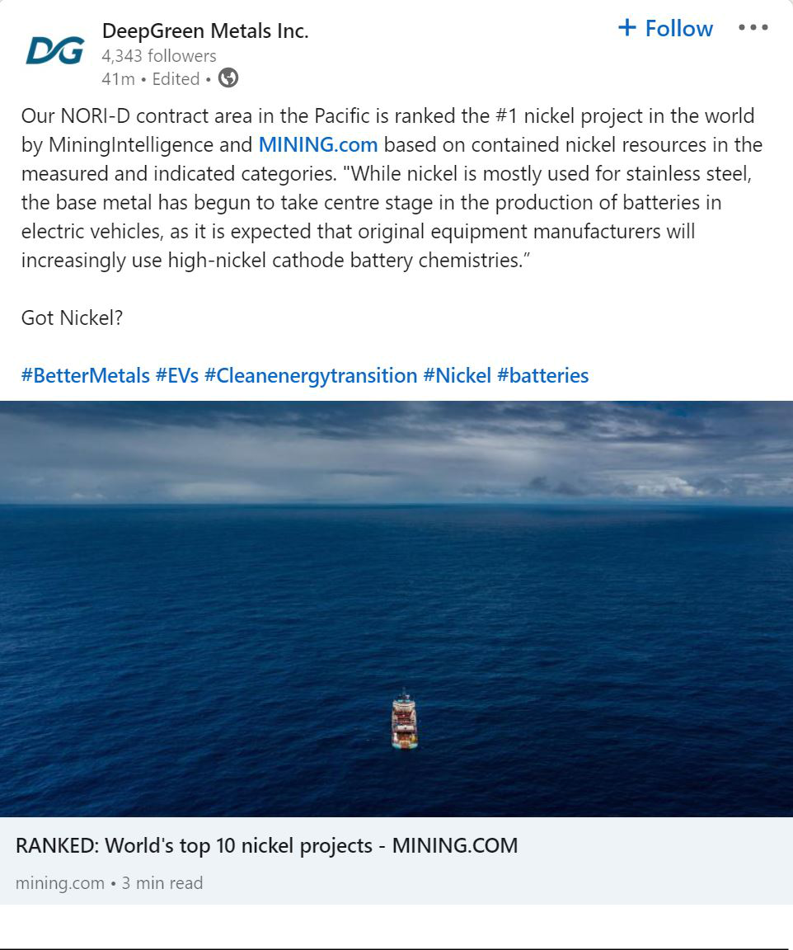

The following communication was made available by DeepGreen Metals Inc. on Facebook on March 19, 2021:
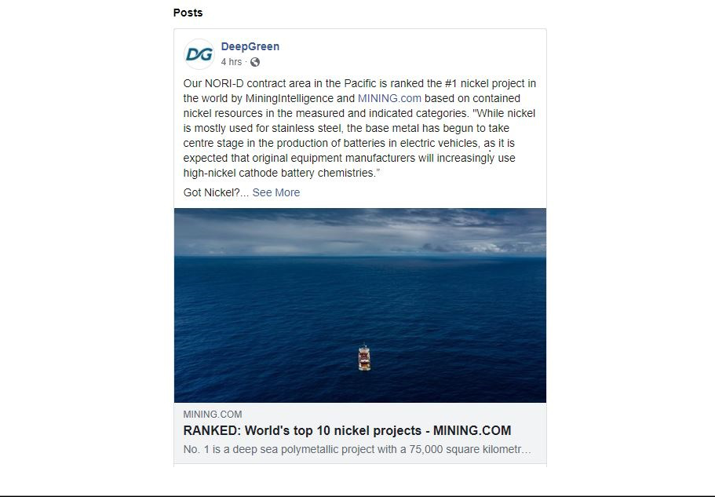

The following communication about DeepGreen Metals Inc. was made available in the aforementioned LinkedIn and Facebook posts on March 19, 2021:
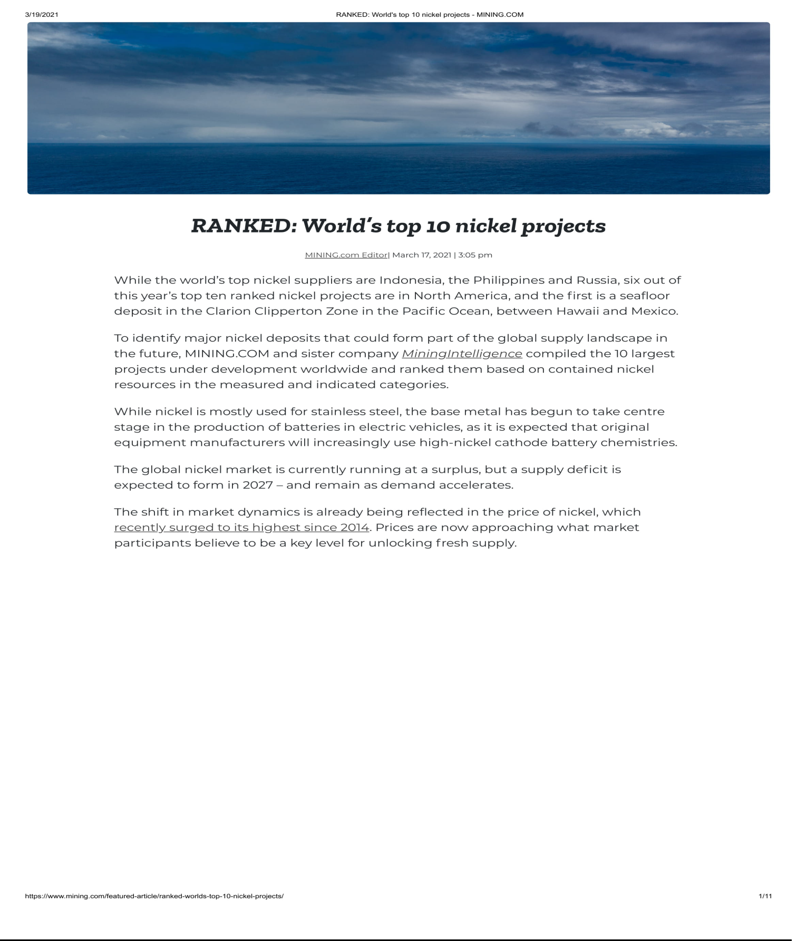

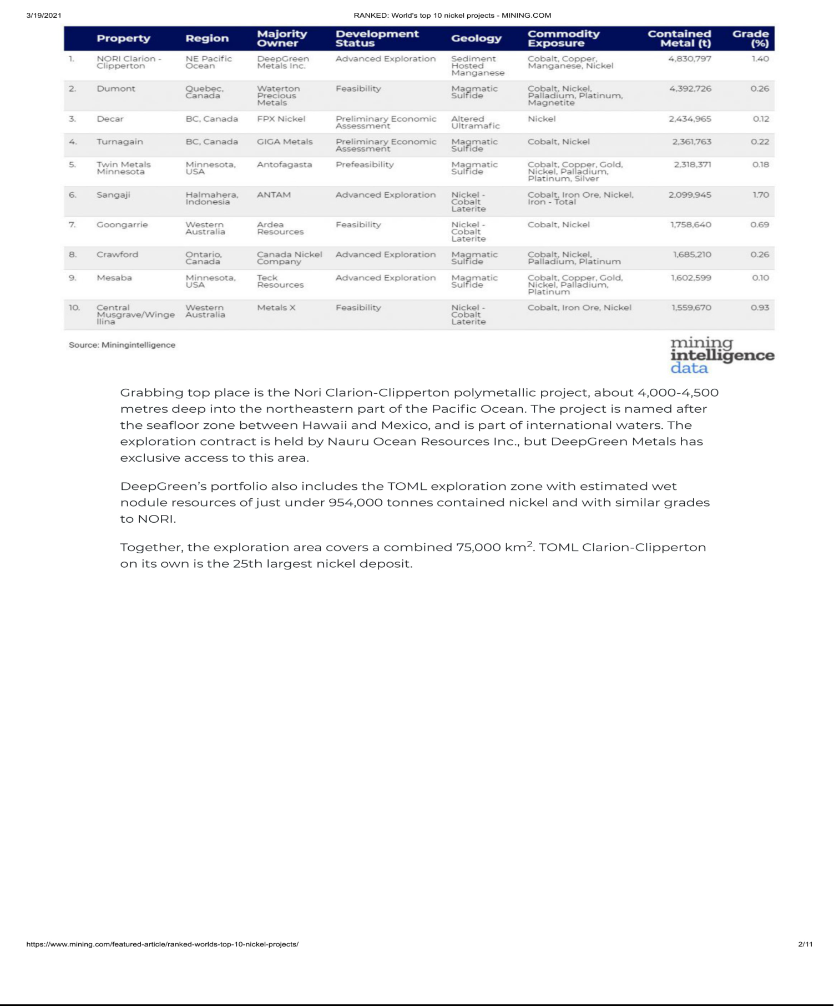

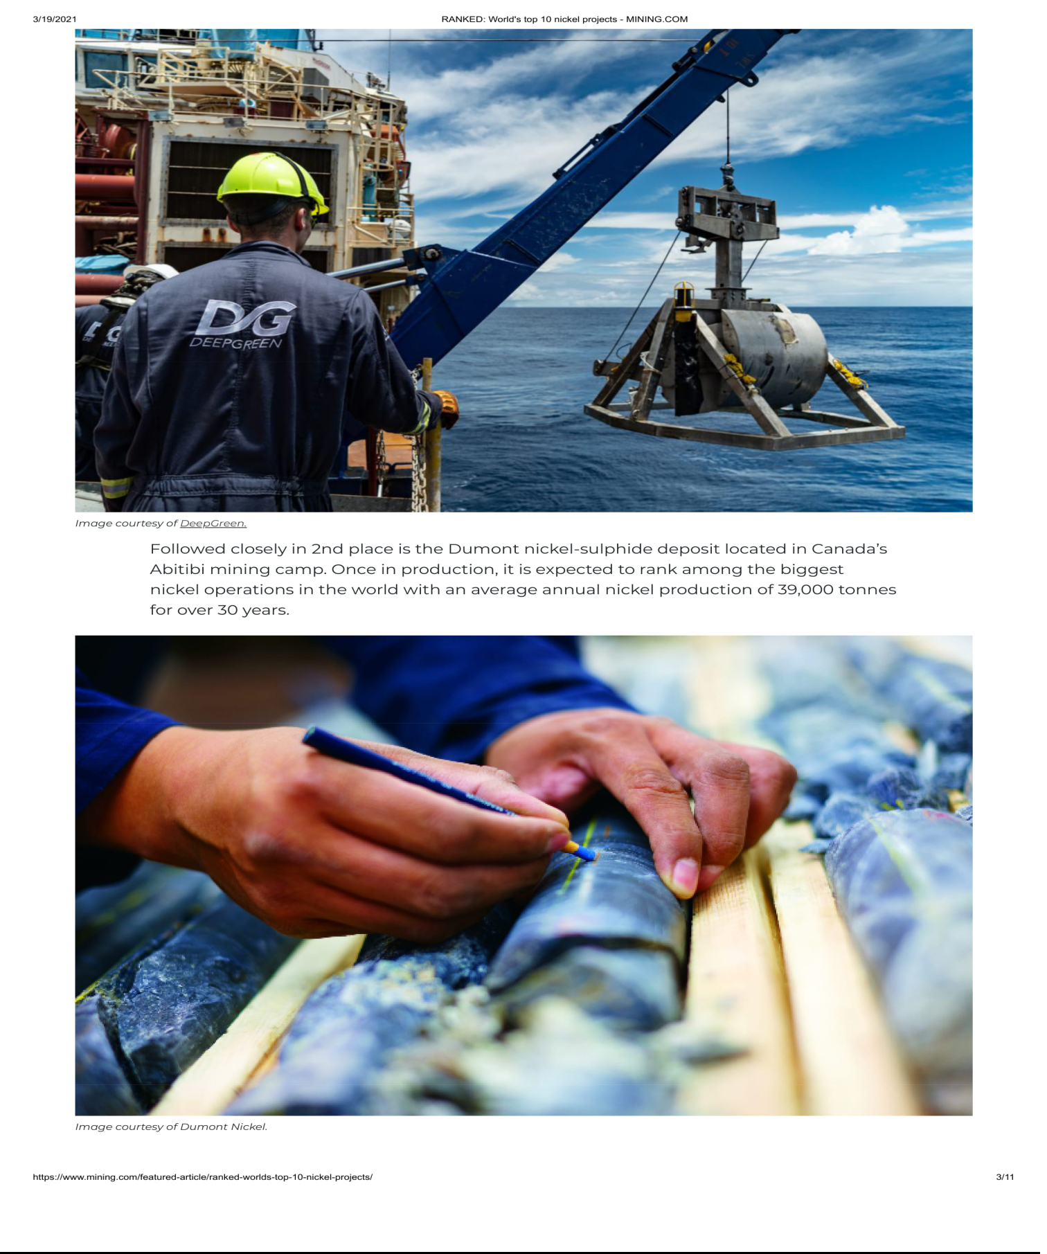

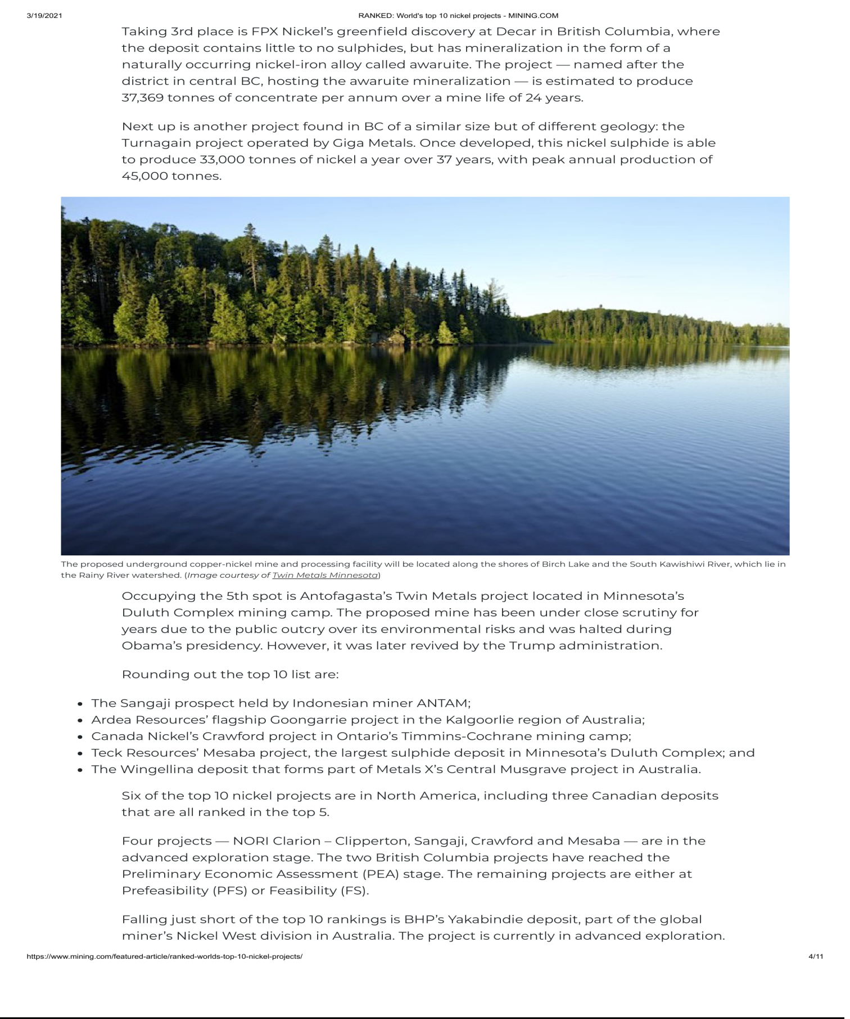

Additional Information

This communication is being made in respect of a proposed business combination transaction contemplated by the business combination agreement (the

“Business Combination Agreement”), dated as of March 4, 2021, by and among Sustainable Opportunities Acquisition Corp. (“SOAC”), 1291924 B.C. Unlimited Liability Company, an unlimited liability company existing under the laws of British Columbia, Canada, and DeepGreen Metals Inc., a company existing under the laws of British Columbia, Canada (the “Company” or “DeepGreen”) and other concurrent agreements related thereto (together, the “Business Combination”). In connection with the proposed Business Combination, SOAC intends to file with the U.S. Securities and Exchange Commission’s (“SEC”) a Registration Statement on Form S-4, including a preliminary proxy statement/prospectus and a definitive proxy statement/prospectus with the SEC. SOAC’s shareholders and other interested persons are advised to read, when available, the preliminary proxy statement/prospectus and the amendments thereto and the definitive proxy statement/prospectus as well as other documents filed with the SEC in connection with the proposed Business Combination, as these materials will contain important information about DeepGreen, SOAC, and the proposed Business Combination. When available, the definitive proxy statement/prospectus and other relevant materials for the proposed Business Combination will be mailed to shareholders of SOAC as of a record date to be established for voting on the proposed Business Combination. Shareholders will also be able to obtain copies of the preliminary proxy statement/prospectus, the definitive proxy statement/prospectus, and other documents filed with the SEC that will be incorporated by reference therein, without charge, once available, at the SEC’s website at www.sec.gov, or by directing a request to: Investors@soa-corp.com.

Participants in the Solicitation

SOAC and its directors and executive officers may be deemed participants in the solicitation of proxies from SOAC’s shareholders with respect to the Business Combination. A list of the names of those directors and executive officers and a description of their interests in SOAC will be included in the proxy statement/prospectus for the proposed Business Combination and be available at www.sec.gov. Additional information regarding the interests of such participants will be contained in the proxy statement/prospectus for the proposed Business Combination when available.

DeepGreen and its directors and executive officers may also be deemed to be participants in the solicitation of proxies from the shareholders of SOAC in connection with the proposed Business Combination. A list of the names of such directors and executive officers and information regarding their interests in the proposed Business Combination will be included in the proxy statement/prospectus for the proposed Business Combination.

Forward Looking Statements

Certain statements made herein are not historical facts but are forward-looking statements for purposes of the safe harbor provisions under The Private Securities Litigation Reform Act of 1995. Forward-looking statements generally are accompanied by words such as “believe,” “may,” “will,” “estimate,” “continue,” “anticipate,” “intend,” “expect,” “should,” “would,” “plan,” “predict,” “potential,” “seem,” “seek,” “future,” “outlook” and similar expressions that predict or indicate future events or trends or that are not statements of historical matters. These forward-looking statements include, without limitation, SOAC and DeepGreen’s expectations with respect to future performance, development of its estimated resources of battery metals, potential regulatory approvals, and anticipated financial impacts and other effects of the proposed Business Combination, the satisfaction of the closing conditions to the proposed Business Combination, the timing of the completion of the proposed Business Combination, and the size and potential growth of current or future markets for the combined company’s supply of battery metals. These forward-looking statements involve significant risks and uncertainties that could cause the actual results to differ materially from those discussed in the forward-looking statements. Most of these factors are outside SOAC’s and DeepGreen’s control and are difficult to predict. Factors that may cause such differences include, but are not limited to: the occurrence of any event, change, or other circumstances that could give rise to the termination of the Business Combination Agreement; the outcome of any legal proceedings that may be instituted against SOAC and DeepGreen following the announcement of the Business Combination Agreement and the transactions contemplated therein; the inability to complete the proposed Business Combination, including due to failure to obtain approval of the shareholders of SOAC and DeepGreen, certain regulatory approvals, or satisfy other conditions to closing in the Business Combination Agreement; the occurrence of any event, change, or other circumstance that could give rise to the termination of the Business Combination Agreement or could otherwise cause the transaction to fail to close; the impact of COVID-19 on DeepGreen’s business and/or the ability of the parties to complete the proposed Business Combination; the inability to obtain or maintain the listing of the combined company’s shares on NYSE or Nasdaq following the proposed Business Combination; the risk that the proposed Business Combination disrupts current plans and operations as a result of the announcement and consummation of the proposed Business Combination; the ability to recognize the anticipated benefits of the proposed Business Combination, which may be affected by, among other things, the commercial and technical feasibility of seafloor polymetallic nodule mining and processing; the supply and demand for battery metals; the future prices of battery metals; the timing and content of ISA’s exploitation regulations that will create the legal and technical framework for exploitation of polymetallic nodules in the Clarion Clipperton Zone; government regulation of deep seabed mining operations and changes in mining laws and regulations; environmental risks; the timing and amount of estimated future production, costs of production, capital expenditures and requirements for additional capital; cash flow provided by operating activities; unanticipated reclamation expenses; claims and limitations on insurance coverage; the uncertainty in mineral resource estimates; the uncertainty in geological, hydrological, metallurgical and geotechnical studies and opinions; infrastructure risks; and dependence on key management personnel and executive officers; and other risks and uncertainties indicated from time to time in the final prospectus of SOAC for its initial public offering and the proxy statement/prospectus relating to the proposed Business Combination, including those under “Risk Factors” therein, and in SOAC’s other filings with the SEC. SOAC and DeepGreen caution that the foregoing list of factors is not exclusive. SOAC and DeepGreen caution readers not to place undue reliance upon any forward-looking statements, which speak only as of the date made. SOAC and DeepGreen do not undertake or accept any obligation or undertaking to release publicly any updates or revisions to any forward-looking statements to reflect any change in its expectations or any change in events, conditions, or circumstances on which any such statement is based.

